"Diary of a CEO" by Steven Bartlett

**Pros:**

* **Relatable and Inspiring:** Bartlett's writing style is often described as relatable and engaging, making complex business concepts accessible to a wider audience. His personal story of building a successful business from a young age is inspiring.
* **Practical Insights:** The book offers practical advice and frameworks based on Bartlett's experiences, covering topics like leadership, marketing, and scaling a business. It's not just theory; it's grounded in real-world application.
* **Honest and Vulnerable:** Bartlett shares his failures and struggles alongside his successes, offering a more realistic view of entrepreneurship and leadership. This vulnerability can resonate with readers facing similar challenges.
* **Broad Business Coverage:** The book touches upon a wide range of business topics, providing a good overview for aspiring entrepreneurs or those looking to improve their existing businesses.
* **Actionable Advice:** The book often provides actionable steps and strategies that readers can implement in their own ventures.

**Cons:**

* **Subjective and Anecdotal:** While the book offers valuable insights, it's primarily based on Bartlett's personal experiences. This makes it subjective, and the advice may not be universally applicable to all situations or industries.
* **Potential for Bias:** As the book is based on one person's journey, there's a potential for bias in the presented information. Readers should consider other perspectives and resources.
* **Marketing Element:** Some critics argue that the book has a strong marketing element, promoting Bartlett's personal brand and businesses.
* **Not Deeply Academic:** While practical, the book isn't a deeply academic or research-based exploration of business principles. It's more of a personal narrative with business lessons woven in.
* **Oversimplification:** To make concepts accessible, some argue that the book oversimplifies complex business challenges and solutions. Real-world scenarios are often more nuanced.

# The 33 Laws for success in business and life

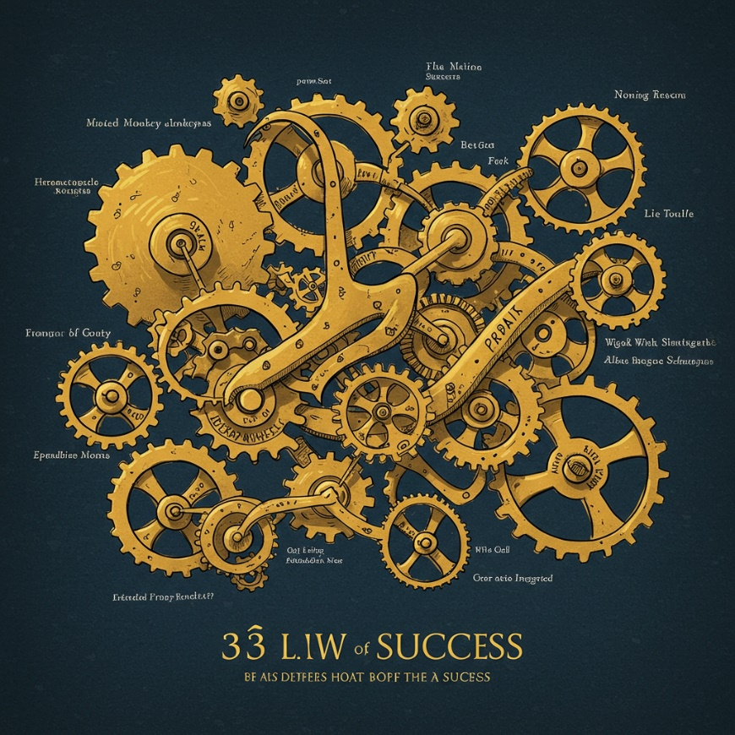

* Pillar #1 - **The Self**:
  1. Fill your five buckets in the right order
  2. To master it, you must create an obligation to teach it
  3. You must never disagree
  4. You do not get to choose what you believe
  5. You must lean into bizarre behavior
  6. Ask, don’t tell – the question behavior effect
  7. Never compromise your self-story
  8. Never fight a bad habit
  9. Always priorities your first foundation
* Pillar #2 – **The Story**:
  1. Useless absurdity will define you more than useful practicalities
  2. Avoid wallpaper at all costs
  3. You must piss people off
  4. Shoot your psychological moonshots first
  5. Friction can create value
  6. The frame matters more than the picture
  7. Use Goldilocks to your advantage
  8. Let them try and they will buy
  9. Fight for the first five seconds
* Pillar #3 – **The Philosophy**:
  1. You must sweat the small stuff
  2. A small miss now created a big miss later
  3. You must out-fail the competition
  4. You must become a plan A thinker
  5. Don’t be an ostrich
  6. You must make pressure your privilege
  7. The power of negative manifestation
  8. Your skills are worthless, but your context is valuable
  9. The discipline equation: death, time and discipline
* Pillar #4 – **The Team**:
  1. Ask who not how
  2. Create a cult mentality
  3. The three bars for building great teams
  4. Leverage the power of progress
  5. You must be an inconsistent leader
  6. Learning never ends

## To master it, you must create an obligation to teach it – 19 Feb 2025

Steven Bartlett's book, "The Diary of a CEO," highlights 33 laws for success in business and life. One principle, is particularly impactful and resonated very well with me is "**To master it, you must create an obligation to teach it.**" This idea centers on the powerful connection between teaching and deep learning. Explaining a concept to someone else necessitates a thorough understanding, forcing you to organize your knowledge, identify any gaps, and articulate clearly. This process solidifies your own grasp of the subject and pinpoints areas for improvement.

This principle works by:

* **Forcing deep understanding:** Teaching requires active processing of information, going beyond passive consumption to make connections and anticipate questions.
* **Identifying knowledge gaps:** Preparing to teach inevitably reveals areas where your understanding is incomplete, highlighting what needs further study.
* **Enhancing retention:** Explaining concepts strengthens memory and recall.
* **Developing communication skills:** Teaching hones the ability to communicate complex ideas clearly and engagingly.

To apply this principle:

* **Seek teaching opportunities:** Volunteer to mentor, lead workshops, or give presentations.
* **Explain concepts to others:** Practice explaining what you're learning to friends, family, or colleagues.
* **Create content:** Writing blog posts, making videos, or sharing knowledge on social media are all forms of teaching.

Essentially, this law emphasizes that teaching isn't just about disseminating knowledge; it's a potent tool for achieving mastery.

## You must lean into bizarre behavior – 20 Feb 2025

In Steven Bartlett's book, "The Diary of a CEO: The 33 Laws of Business and Life," the law "You must lean into bizarre behavior" isn't about endorsing truly strange or inappropriate actions. Instead, it's a call to embrace the unconventional, the new, and the things that might initially seem strange or uncomfortable.

Here's a breakdown of what it means:

* **The world is changing rapidly:** Bartlett emphasizes the accelerating pace of change, particularly in technology and business. What seems bizarre today might be commonplace tomorrow.
* **Resist cognitive dissonance:** When faced with something new that conflicts with our existing understanding, we often experience discomfort (cognitive dissonance). Our natural tendency is to dismiss the new thing to resolve this discomfort.
* **Lean in, don't lean out:** Instead of dismissing the unfamiliar, Bartlett encourages us to "lean in" – to be curious, ask questions, and explore the possibilities. This is how we discover new opportunities and stay ahead of the curve.
* **Innovation often feels bizarre:** Breakthroughs and innovations often seem strange or even ridiculous at first. Think of the early days of the internet or the first iPhone. Those who dismissed these "bizarre" ideas missed out on huge opportunities.
* **Embrace discomfort:** Leaning into the bizarre means being willing to step outside your comfort zone and challenge your own assumptions. It's about recognizing that growth and progress often come from exploring the unknown.

**In essence, "leaning into bizarre behavior" is a mindset of curiosity, open-mindedness, and a willingness to embrace change, even when it feels uncomfortable or unfamiliar.** It's about recognizing that the future belongs to those who are willing to explore the unconventional and challenge the status quo.

## You must be an inconsistent leader – 28 Feb 2025

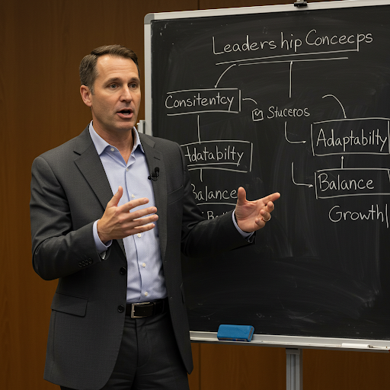

This law seeming contradicting to popular leadership beliefs! It does appear counterintuitive to say a leader should be inconsistent when so much leadership advice emphasizes on consistency. However, like the "lean into bizarre behavior" law, this isn't about being erratic or unreliable. It's about a more nuanced approach to leadership.

Here's how Steven Bartlett likely intends "You must be an inconsistent leader" to be understood:

* **Adaptability is key:** The world changes rapidly, and leaders need to be able to adapt their strategies, approaches, and even their communication styles to fit different situations. Rigidity and sticking to the same methods regardless of context can be a recipe for disaster.
* **Context matters:** What works in one situation might not work in another. A good leader recognizes this and adjusts their behavior and leadership style accordingly. This might mean being decisive and directive in a crisis but more collaborative and empowering when the team is working on a long-term project.
* **Balance is crucial:** Inconsistency doesn't mean being completely unpredictable. There needs to be a core set of values and principles that remain consistent. However, within that framework, leaders should be flexible and willing to adjust their approach as needed.
* **Humanity over robotic consistency:** People aren't robots, and neither should leaders be. Showing some vulnerability, acknowledging mistakes, and adapting to the emotional needs of the team can be seen as "inconsistent" by some, but it can also build trust and connection.
* **Growth mindset:** A leader with a growth mindset understands that there's always room to learn and improve. This might mean changing their mind about something, adopting new strategies, or even admitting they were wrong. This kind of evolution can be perceived as inconsistency but is ultimately a sign of strength.

**In essence, "being an inconsistent leader" is about being adaptable, context-aware, and human. It's about finding the right balance between consistency in core values and flexibility in approach.** It's not about being unpredictable or unreliable, but rather about being responsive to the ever-changing needs of the situation and the team.

## A small miss now creates a big miss later

This principle, "A small miss now creates a big miss later," from Steven Bartlett's book, *The Diary of a CEO*, emphasizes the importance of **attention to detail and the compounding effect of seemingly minor errors or oversights.** Here's a breakdown of what it means:

**The Core Idea:**

* **Small misses accumulate:** In business, as in life, small mistakes, neglected tasks, or missed opportunities might seem insignificant in the moment. However, these small misses can compound over time, like a snowball rolling downhill.
* **Compounding consequences:** Each small miss weakens the foundation or creates a vulnerability. As more small misses occur, the cumulative effect grows, leading to larger, more significant problems down the line.
* **Big miss as the outcome:** Eventually, the accumulation of these small misses can manifest as a major failure, a missed deadline, a lost client, or a significant financial setback – a "big miss."

**Examples:**

* **Ignoring minor customer complaints:** A single unanswered email or a delayed response might not seem like a big deal. But if this becomes a pattern, customers may feel undervalued and take their business elsewhere, leading to a significant loss of revenue.
* **Neglecting small maintenance issues:** Postponing a minor repair on a piece of equipment might seem like a way to save money in the short term. However, that small issue could worsen, leading to a major breakdown that halts production and costs far more to fix.
* **Failing to address a small performance gap:** An employee's minor underperformance might be overlooked initially. But if this isn't addressed, the employee's performance may continue to decline, impacting team productivity and potentially leading to their eventual dismissal.

**Key Takeaways:**

* **Sweat the small stuff:** This principle highlights the importance of paying attention to the details. No task is too small or insignificant to be overlooked.
* **Proactive problem-solving:** Addressing small issues promptly can prevent them from escalating into larger problems.
* **Long-term vision:** Consider the long-term consequences of your actions, even the seemingly minor ones.
* **Accountability:** Take responsibility for even the smallest of tasks and ensure they are completed to a high standard.

**In essence, "A small miss now creates a big miss later" is a reminder that success is built on a foundation of consistent attention to detail and a commitment to excellence in all areas, no matter how small they may seem.**

